The Learning Center Program Review 2017-2018
Part II: Analysis of Program
Testing
The Learning Center (TLC) offered a range of testing services for students, faculty, and the community. TLC testing center coordinator manages college placement testing, UHMC (make-up, disability accommodated exams, special class proctoring) testing, distance learning testing for the 10 campuses, and community proctoring including the administration of employment certification exams and being a recognized testing center for county and state agencies. TLC testing coordinator routinely collaborates with disability services, instructional departments, and student support areas to support various student assessment needs across the campus. Throughout the year, Our TLC staff strived to maintain high quality testing services and standards. We follow the National College Testing Association standards which serves as a model for postsecondary test centers.
TLC staff proctored 4,684 tests during the 2017-2018 school-year. This is about an 18% decrease in test administrations from the previous year; however, it mirrors the college’s and University’s overall enrollment trend which has steadily declined over the last couple of years. Figure 1 illustrates the testing trends over the last two years. All areas of testing including placement, distance learning, community proctoring and make up testing declined in 2017-2018. Although, community and certification testing decreased, TLC generated $22,500 in revenue through community proctoring, and onboarded two new community tests: GRE and TOEFL to address our community’s testing needs.
Figure 1
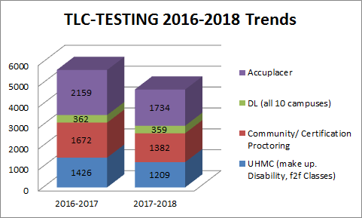
We used testing revenue to purchase 20 new computers to replace half of our 40 computer test stations and update the testing center camera system which was first installed in 2014,. The modification included purchasing and installing additional cameras in the testing center to increase test security. We also purchased more locking bags so test takers can keep their valuables in a locked bag on the back of their testing chair. Upon completion of the test, the proctor unlocks the bag and the test taker can remove their valuables and proceed with check-out. We used testing revenue to provide professional development for our TLC staff and to purchase supplies for our student employee training program.
TLC was open for testing 5 days a week. The center had two 1.0 FTE APT B staff positions, a 1.0 FTE Director position,1 APT A (Casual), and student assistants. The testing center is part of a larger learning center that also provides tutoring and other learning support services for UHMC students. TLC staff and student assistants shared duties for maintaining learning support and testing. Aside from community proctoring and those UHMC students who reserve TLC Quiet Room, test proctoring was provided on a walk-in basis. Overall, data from TLC satisfaction survey indicated that 100% of respondents felt the testing services were very good or excellent.
Learning Center
Tutoring
Since the incarnation of TLC, the peer tutoring program has been one of its primary functions; although, TLC is not the only support area on campus that provides tutoring. Figure 2 shows the breakdown of TLC tutoring per department with most of our tutoring resources going to English, STEM and Business. Tutoring sessions were 30 minutes in length and required an appointment; although, we accept walk-ins for those who needed immediate assistance and assist all students using TLC as needed. TLC provided tutoring 6 days a week for 2017-2018 school-year.
Figure 2
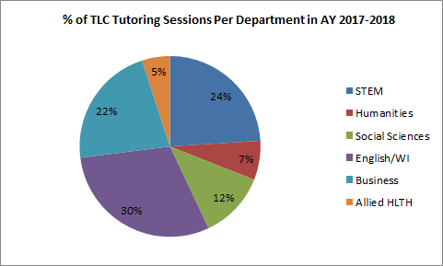
Peers tutors provided 926 hours of tutoring during the 2017-2018 academic year. In addition to providing face to face tutoring, TLC staff managed the online tutoring service, Brainfuse. Online tutoring, has become a crucial part of TLC support services, and the only way to provide support for our distance learners as well as those who cannot come to TLC during its hours of operation (37% of users logged on between hours of 11:00 P.M. and 2:00 A.M.). Additionally, it helps us to provide tutoring for some courses that we have struggled to find peer tutors for in the past including some of upper level ABIT courses. Brainfuse provided 1294 hours of tutoring for UHMC students during the 2017-2018 school-year. Usage increased from 2016-2017. Figure 4 shows the percentage of usage for TLC Peer Tutoring and Brainfuse, online tutoring.

Figure 4
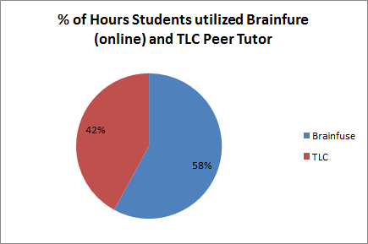

A recent study conducted by Brainfuse for the UHCC system office entitled The Impact of Online Tutoring on Retention, Success and Graduation Rates at the UHCC’ s (2016) found the following:
- UHCC fall to fall retention rates for students utilizing online tutoring were 11% higher than the retention rates of UHCC students as a whole. UHMC’s retention rate was 8% higher than the comparison group.
- The fall to fall retention rates for student utilizing online tutoring increased in a linear fashion to hours of tutoring utilized.
- The number of UHCC students utilizing online tutoring retained resulted in an estimated $676,272 in tuition revenue. UHMC’s estimated tuition revenue was $92,225.
- Success and graduation rates for UHCC students utilizing at least four hours of online tutoring were 6% higher than those of the UHCC students as a whole. UHMC was 3% higher than the comparison group.
- Retention rates were higher for all socioeconomic levels of the UHCC students that utilized Brainfuse compared to the rates of UHCC students as a whole.

Lastly, TLC staff provided in-class tutoring for English and Psychology courses; this has helped us to provide crucial support to many students who have been difficult to reach in the past. In 2017-2018 school-year, 196 unduplicated students received consistent weekly peer tutoring through in-class tutoring. Many of these students, also attended tutorial sessions with their in-class tutors outside of class. As figure 5 shows, all students received support from the in class tutor for 3-6 hours per week during their class, and about 9 hours per week of tutoring by the in class tutor outside of class.

Figure 5
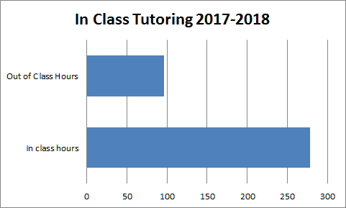

On 2017-2018 TLC satisfaction survey, 98% of respondents perceived that tutoring very much or somewhat helped to improve their course grade. On the 2018 CCSSE, 72% of respondents indicated that tutoring was a very or somewhat important service that the College provides. 42% indicated that they frequently or somewhat frequently used tutoring services, and 42% indicated they were satisfied with the tutoring services. 58% of respondents indicated that they rarely or never used tutoring. Although the CCSSE respondents were commenting on tutoring in general, the quality of our tutoring sessions are important to us and integrating the learning support directly into the classes is a model we would like to experiment with in other courses like WI and FYE course sections. We know from tracking data and feedback from our in class tutors that the relationship development between the in class tutor and the students during the class normalizes and drives peer tutoring sessions outside of class.

Orientation and Learning Strategy Workshops

It is important to introduce TLC to as many students as possible. To this end, TLC staff provide 20 minute orientations to classes including developmental English, Culinary, ENG 100, Psychology, and Social Sciences. We also send a short online orientation video describing our services directly to UHMC students through MySuccess.

All of TLC’s learning strategy workshops were available online at our website. We provided contextualized learning strategy workshops for courses based upon instructor request. In spring 2017, we also worked with the first year (FY) faculty to identify existing ways they were addressing the FY goals in their classes. From these conversations with faculty, we identified gaps in student academic support, and we (TLC Staff) developed Start Smart: Essential College Skills, a free, online laulima course focused on the development of organizational strategies, academic skills, and motivation and grit. 856 students enrolled in the course during the 2017-2018 AY, much fewer have been active (about 256). FY students (about 495) were automatically enrolled while the remainder requested access. A couple of faculty required it in their classes which helped to improve usage.

We provided access to other online self-paced, self-directed courses (EdReady Math, College English Preparation, and Grammar Fitness) for students to improve or just review their reading, writing, grammar, and math. These interactive courses provide individualized instruction and practice activities based on an initial diagnostic test. During the 2017-2018 school-year, 56 students signed up and completed the initial diagnostic. Of these, 45 completed their individualized program, and improved their post test scores.
Computer Lab and Study Area
During the 2017-2018 school-year, we maintained a 23 station computer lab (both Mac and PCs), a scanner, printer, and copier as well as other office/school supplies to facilitate completion and submittal of course assignments. When the lab was full we provided laptops (20) to students for use within TLC to complete their work. The TLC staff flow in and out of the lab assisting students. We logged 197 different impromptu tutoring sessions on basic computer usage and Laulima. Although, we encourage staff and peer receptionists to log these impromptu sessions, it is very difficult to track them as we are assisting students with computer functions/software issues at all levels throughout the day. We also worked with the IT department and course instructors to ensure the computer software was up to date and relevant to the courses taught during the fall and spring semesters. TLC uses the money collected from testing revenues to upgrade computers and purchase supplemental study materials and programs.
In the past year, the TLC staff provided an inviting place to study both individually and in small groups. Many faculty kept textbooks and other resources on reserve at the TLC for students to access. The TLC also provided a quiet room that students reserve so they could test or study in a distraction free environment. Overall, TLC’s staff were and are its greatest strength. We worked hard to create a friendly and welcoming place where students felt comfortable using the resources and seeking help.
2018 CCSSE data indicated that 51% of respondents were utilizing a computer lab (like TLC) on campus, and 55% indicated that they were satisfied with the computer lab.
Part III Action Plan
Testing
TLC staff continues to focus on the quality of test administration as it follows post-secondary testing center standards and guidelines. The following action plan articulates how the TLC testing center plans to move forward over the next year.

Activity | Person(s) Responsible | Timeframe
Continue to monitor testing center hours to maintain test security while accommodating UHMC students | Testing Coordinator and TLC Director | Ongoing
Increase number of national/standardized tests proctored - research TESOL, CLEP | Testing Coordinator and TLC Director | Completed by June 30, 2019
Continue to Implement National College Testing Association Standards and Guidelines for Post -Secondary test centers | Testing Coordinator and TLC Director | Ongoing

Tutoring and Other Support
TLC staff offers tutoring, computer lab services, and study area for students 6 days a week. Increasing usage of the TLC’s resources especially, peer and online tutoring and Start Smart: Essential College Skills is our primary focus for the 2017-2018 school year.
Activity | Person(s) Responsible | Timeframe
Develop stronger partnerships with instructional and student services faculty to integrate TLC services into course requirements and early alert systems/interventions. | TLC Director | Ongoing
Work with counseling, instructional faculty, support staff, and students to utilize MySuccess and turnaround struggling students | TLC Director and Tutor/ Technology Coordinator | 2018-2019
Strengthen MySuccess usage/training as a way to promote a team based approach for helping struggling students in a timely manner. | TLC Director and Tutor/ Technology Coordinator | 2018-2019
Improve Start Smart. - build content | TLC Director | Ongoing
Increase number of students utilizing TLC resources - tutoring, computer lab, learning resources.. | TLC Director and Marketing Coordinator | Ongoing
Expand in-class tutoring to FY and WI course sections. | TLC Director and Tutor/ Technology Coordinator | Ongoing
Continue to provide online tutoring services for more UHMC 2 year and 4 year courses | TLC Director | Ongoing
Research, identify and procure new printing system for academic support areas. | TLC Director, Library Chair, IT coordinator, Molokai Outreach Coordinator, VCAA | 2018-2019

Part IV: Resource Implications
Testing
None at this time.
Tutoring
We are requesting $30,000 annually to fund online tutoring. Online tutoring is an essential service for distance learning students and those whose jobs and families prevent them from being able to use TLC or other tutoring labs and Outreach Centers during their hours of operation. Online tutoring also helps us to provide content and research writing skills support for our students taking upper division courses, and we would like to work towards expanding the number of upper division courses tutored through Brainfuse, and thus, increase support for students working towards UHMC baccalaureate degrees as well as associate degrees. This request meets Strategic Direction themes: Student Success, Quality of Learning, and Community and Workforce Development.

The Impact of Online Tutoring on Retention, Success and Graduation Rates at the University of Hawaii Community Colleges Summer 2013-Fall 2015. Released on June 1, 2016.

